COSC 3380

Name: Jose Del Villar PS ID# 1609567
Project 3:
(100 points.)
(Due date found in the COSC 3380 Detailed Syllabus!)

1. a. Create stored procedure PatientQuery ___ _______ 20 points
1. b. Run PatientQuery __ ______ 10 points

2. a. Create trigger CodeUpdate _______ 20 points
2. b. Run trigger CodeUpdate ________ 10 points

3. JSP Web Page Accounting.jsp ___ 40 points

PLEASE ENTER YOUR GRADE IN THIS BOX & ALSO on the CHECK SHEET:

Use the COSC3380 Database created in Project 2.

Part 1. (30 points) Stored Procedures
1. (30 points)
a. (20 points) Create a simple procedure PatientQuery that will take the SessionNumber (the primary key for Sessions table) as a parameter and display SessionNumber, Session Date, PatientNumber (key), Patient LastName, PatientFirstName.
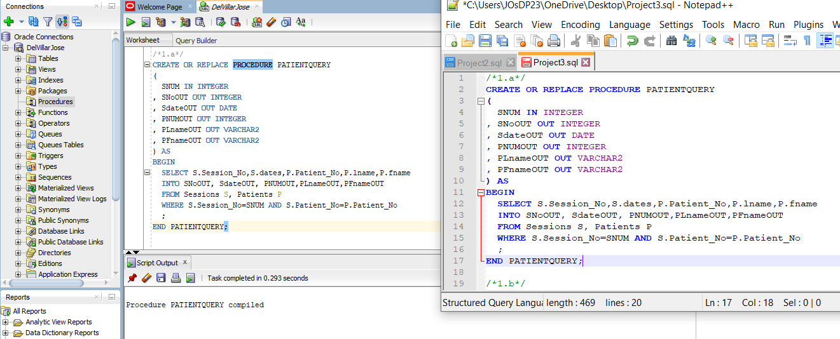

b. (10 points) Run the PatientQuery procedure in Oracle with 2 different arguments (30 and 35).
/*1.b.1*/
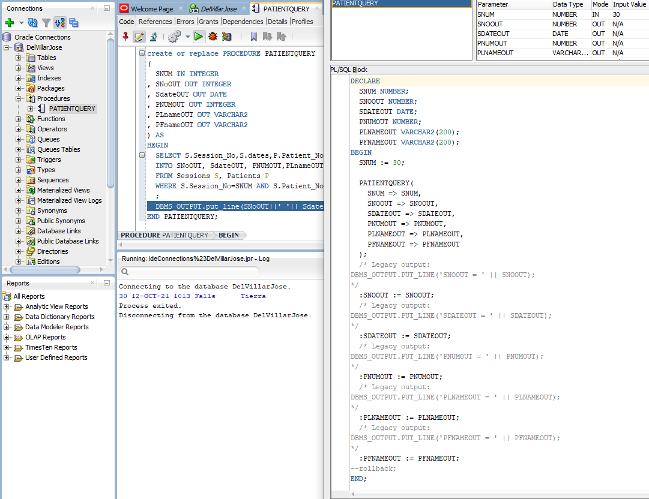

/*1.b.2*/

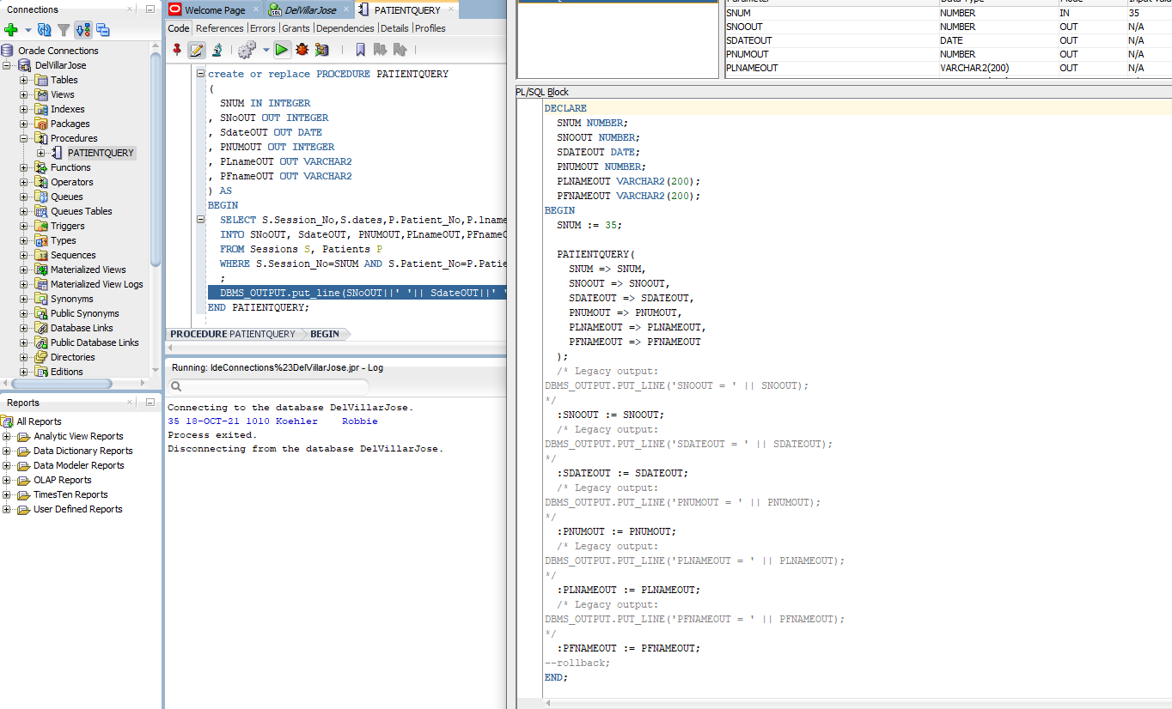
Part 2. TRIGGERS (30 points)

- (20 points) Write and
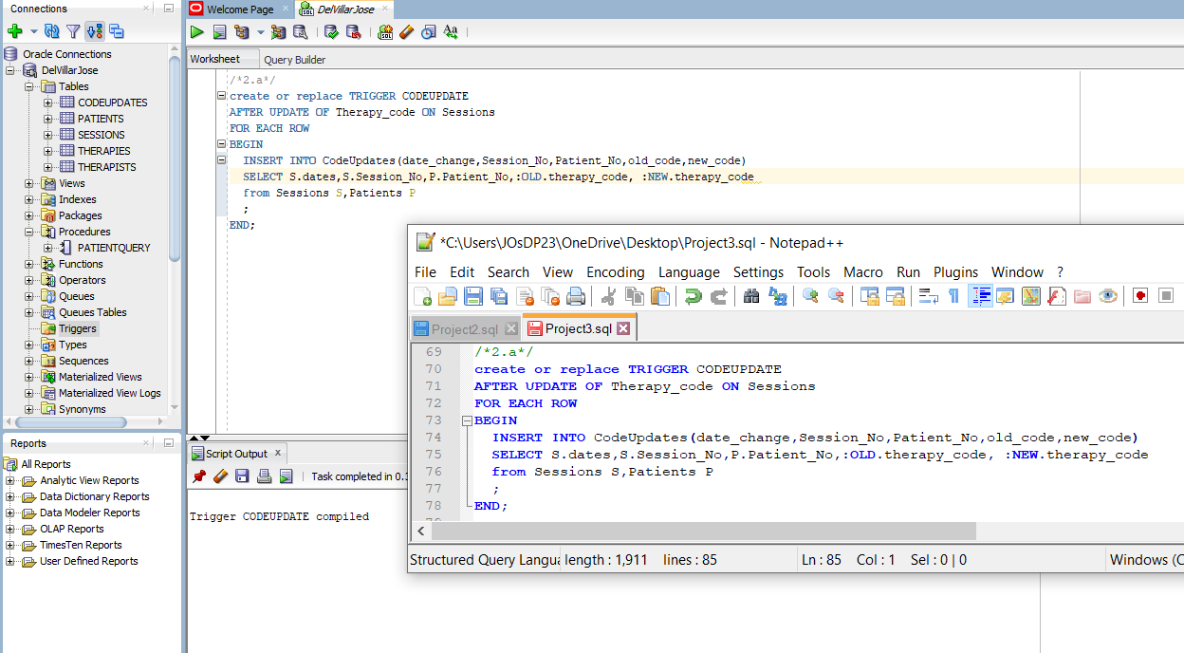
- (10 points) Run the trigger named CodeUpdate
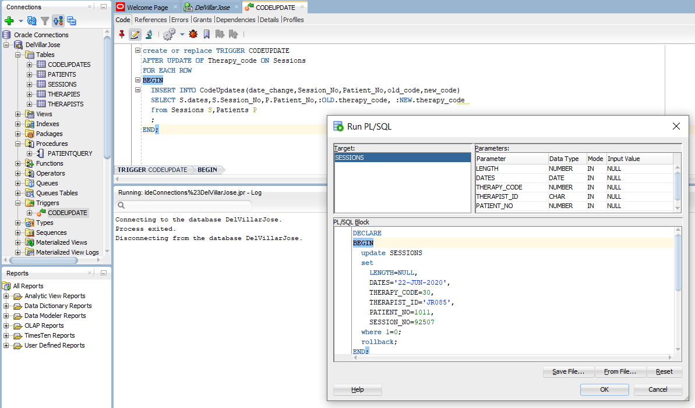

Part 3. (40 points) Accessing COSC3380 Database from JSP
A JSP Web Page (40 points)

Accounting web page needs to display patient number, patient last and first name, session date and session number sorted in chronological order last name, first name.

Create Accounting.jsp

(jsp page oracle 12c DBMS backend)

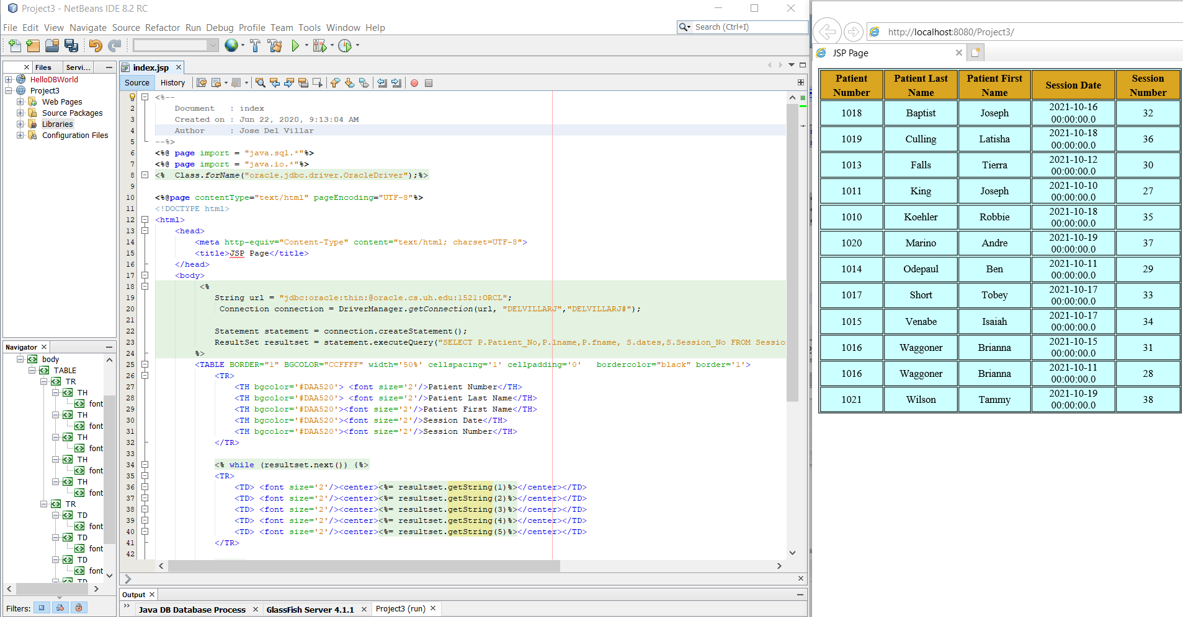

You need to turn in hard copy and electronic:
. The .sql scripts with comments, Project3.sql.
. The .zip of the 3 Projects (2 NetBeans; 1 Visual Studio).

. The screenshots of Stored Procedures, Trigger, NetBeans Project, Web Pages AND the source CODE, Project3.doc.

Without Project3.doc you will get ZERO!

